总结报告6

（2019.9.22——2019.9.23）

**一、学习内容：机器学习中的数学：多元微积分WEEK3,WEEK4；**

**机器学习WEEK1（3）：Gradient Descent Algorithm**

1. **Gradient Descent: minimizing the cost function **

Have some function 

Want 

方法：

1. Start with some 
2. Keep changing  to reduce until we hopefully end up at a minimum
3. **Gradient Descent Algorithm**

Repeat until convergence(收敛){



}

**Notice:**

:= assignment(赋值),such as a:=b.

= truth assertion(断言),such as a=b.

 learning rate(how big a step we take when updating my parameter theory j)

**Simultaneous update:**

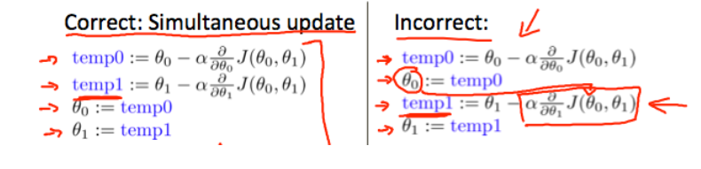

: ifis too small, gradient descent can be slow.

ifis too large, gradient descent can overshoot the minimum. It may fail to converge or even diverge(分叉偏离).

 approaches 0 as we approach the bottom of our convex function. At the minimum, the derivative will always be 0.

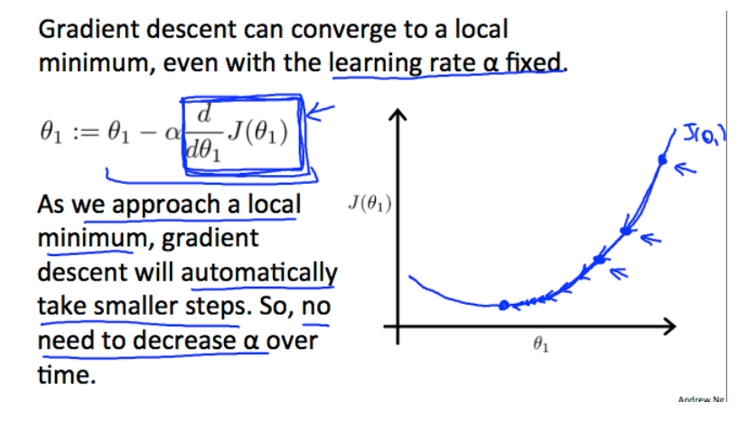



**Notice:**

**“Batch” gradient descent**

“Batch”: Each step of gradient descent uses all the training examples.

**3、Artificial Neural Networks**(image recognition/language translation)

(1)One input ,One output:

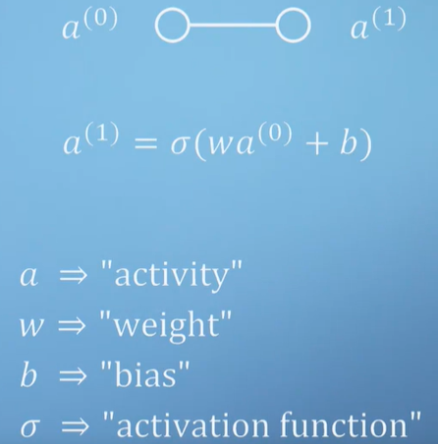****

(2)To vector:

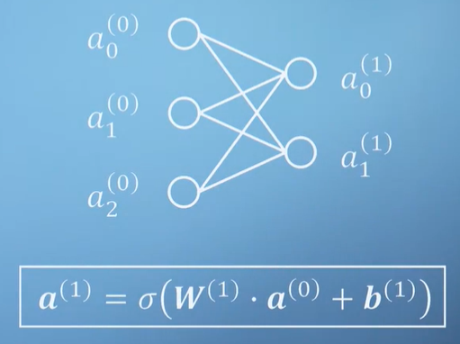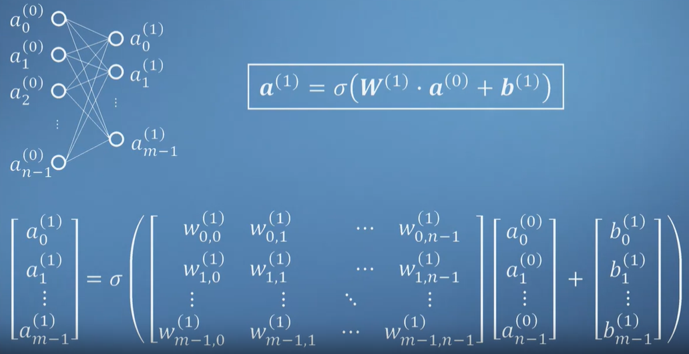

**Notice:**

In general there are as many **biases** as there are output and hidden neurons.

The complexity of a network comes from the information stored in its **weights and biases**. There will simply be more of these for networks with hidden layers, allowing for more complicated functions to be modelled.

(3)Cost Function:



**4、Taylor series(Power series)**

(1)one variable



(2)multivariable(The Jacobian, The Hessian)

